

|  |  |
| --- | --- |
| Student name: | Altay Tomiris |
| Teacher name: | Kalakova Aidana |
| Project name: | Algebraic Calculator |
| Project type: | Individual |
| Number of words | Must be between 1000 and 1500 in total |

**INTRODUCTION**

The most popular problem-solving tools are mostly digital and online due to its convenience, speed and accuracy. “Mathway”, “Geogebra” are good examples of such tools. Middle school students face a lot of obstacles while trying to solve equations that differ from what they’ve done in the past. To ease this, teachers suggest using online calculators,

This program is a problem-solving assistant that instantly solves simple math problems. It provides homework help anywhere, anytime without the need for a network connection.

The project covers:

- Basic mathematics: Basic math simple concept related with mathematics. Generally, counting, [addition](https://www.ipracticemath.com/learn/basicmath/addition), [subtraction](https://www.ipracticemath.com/learn/basicmath/subtraction), [multiplication](https://www.ipracticemath.com/learn/basicmath/multiplication) and [division](https://www.ipracticemath.com/learn/basicmath/division) are called the basic math operation (iPracticeMath, 2020).

- Basic algebra

This program is a tool when you need to solve a problem. It can help with student’s homework and give them an opportunity to practice. All the user needs to do is enter data and click on the button.

By developing a program in the visual programming language Visual studio, deepening and expanding knowledge not only in the C # programming environment, but also in mathematics would be efficient.

Based on the use of this program in the study of the subject of mathematics, it is possible to create conditions for students of grades 7-9 to improve their practical skills in solving problems and consolidate knowledge in the use of formulas.

**MAIN PART**

The project’s main idea is to create a helpful program that displays multiple algebraic functions, which students can use to solve problems when they are not able to. Since the program is way faster, it is also considered to be structured. To achieve this, the defined main tasks are:

• Explore the capabilities of the object-oriented language C #.

• Improve practical programming skills and knowledge when developing a program.

• Develop a program in the object-oriented language Visual Studio.

• Use all 3 algorithms for programming.

• Create a user-friendly interface to make it easier for the user to operate the program.

C# program language - is a derivative of the C programming language and is similar to [C++](https://techterms.com/definition/cplusplus). It uses the same basic operators as C++, is [object oriented](https://techterms.com/definition/oop), case sensitive, and has nearly identical [syntax](https://techterms.com/definition/syntax). However, there are several differences between C# and C++ (Christensson, 2014).

During a series of research, it was revealed that in practice, when solving problems, simple calculators are used. However, it would be more convenient to have a special calculator with built-in, frequently used formulas in mathematics. Solving problems with the help of the developed program will be very comfortable to use, since the program has different functions.

The formulas were chosen considering the fact that basic math can either be remembered for the whole life or forgotten easily. So, the list of the formulas are:

* Abbreviated multiplication (addition)
* Abbreviated multiplication (subtraction)
* Area of circle: the region occupied by the circle in a two-dimensional plane. It can be determined easily using a formula, A = **πr2**, (Pi r-squared) where r is the [radius of the circle](https://byjus.com/maths/radius-of-a-circle/) (BYJUS, 2020).
* Discriminant and two roots: a [parameter](https://www.merriam-webster.com/dictionary/parameter) of an object or system calculated as an aid to its classification or solution. The roots of a quadratic or cubic equation with real coefficients are real and distinct if the discriminant is positive, are real with at least two equal if the discriminant is zero, and include a conjugate pair of complex roots if the discriminant is negative (Britannica, 2020).

**Gant chart**

To have a consistent working schedule, a grant chart was created. Dividing the tasks and subtasks for days, it was steadier to complete the project. As every aspect was done, grant chart was marked at 100%.

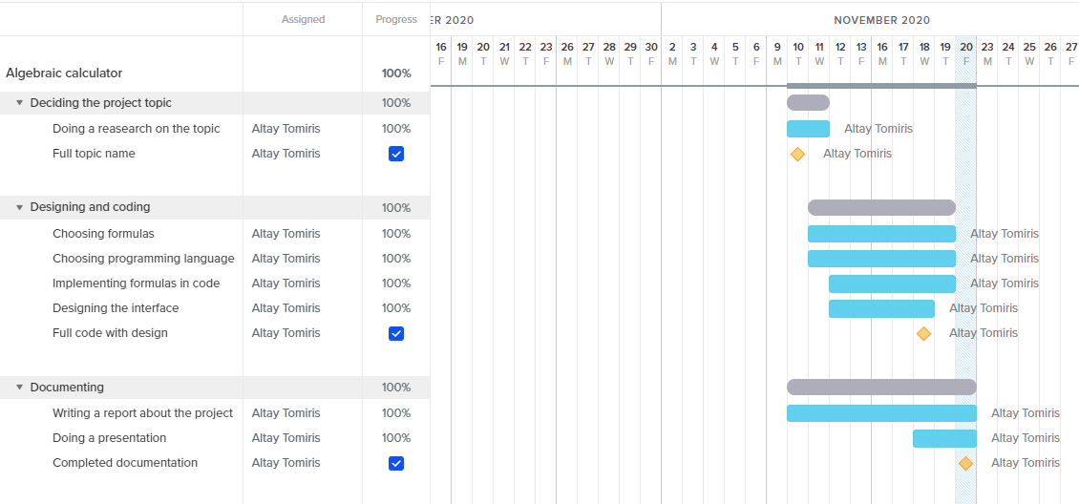

**DAILY PROGRESS**

*(what students learned day by day including all C++ lectures, project works, and guest lecture must be described here)*

|  |  |
| --- | --- |
| 09.11.2020 | On the first day of C++ lecture we renewed out basic knowledge about basic programming such as variables etc.  On the other hand, for my project I decided its title and what is it going to perform. |
| 10.11.2020 | During the guest lecture, I found a lot of useful information about studying abroad as it provides good experience. We also covered if-else statements on C++ lecture and for my project, I was searching for a more operative programming language. |
| 11.11.2020 | I thought of aspects about programming language and its advantages, such as a friendly interface as not so many people are familiar with programming. |
| 12.11.2020 | The guest told about their work experience in Google, I could say it was very helpful to hear from a person who worked in one of the biggest world corporations. For the project, I finally decided in which language I am going to write and it was C#. |
| 13.11.2020 | The today's main goal was to set up an interface, or in other words, design a menu. Looking up several versions of digital calculators, I chose colors as red, so it would bring a focus on the program from the user's side. I added buttons and labels so it would be clear which button leads to certain functions. The lecture was about multi-dimensional arrays, although I already studied it, my knowledge was refreshed, and I remembered details about the topic. Everything explained was very clear and understandable. |
| 16.11.2020 | I started writing codes for my program, such as discriminant, abbreviated multiplication etc. We covered functions on the C++ lecture which was very useful as I am including function codes in my project. |
| 17.11.2020 | Regarding my project, I started designing the background and how it will look overall. So that the interface will tell what the program is about by giving clues, for example, I specifically chose math themes photos for background. |
| 18.11.2020 | Finishing the interface of my project, I was also halfway done with codes too. By creating 2 functions I thought something was lacking so I added a test, to enhance the knowledge covered in math. On C++ lecture we covered pointers, and the guest lecture was about game development which was very entertaining to listen to. |
| 19.11.2020 | During the lecture, we studied structures and how to write them. Teacher told several rules about performing them properly. I removed the test from my code because it looked inconvenient near other formulas, instead I added geometrical formula, because I want to cover more parts of math. |
| 20.11.2020 | On the lecture, teacher taught us how to write strings, giving additional problems to solve. I finished the whole code and design, overall, the project was done. |
|  |  |

**CONCLUSION**

The project’s main aim was to help student struggling with math find easier solution to their problems. They can practice and enhance their knowledge in algebra and geometric formulas. The very basic formulas were chosen for the coding, as it is taught at schools but can be easily forgotten. For example, abbreviated multiplication, discriminant and two roots. Besides algebra, formula of finding the area of circle in geometrics was chosen. These were written in C# programming language and give with a friendly interface so it would not confuse the users. Overall, the project was completed successfully without any major problems.

**Reference List**

1. iPracticeMath, Learn Basic Math. Retrieved 2020, Nov 13, from <https://www.ipracticemath.com/learn/basicmath>
2. BYJUS (2020), Area of a Circle (Definition, Area and Perimeter Formula). Retrieved 2020, Nov 15, from <https://byjus.com/maths/area-circle/>
3. Christensson, P. (2014, June 4). *C# Definition*. Retrieved 2020, Nov 15, from <https://techterms.com>
4. Encyclopedia Britannica (2020, September 18). Discriminant. Retrieved 2020, Nov 17 from <https://www.britannica.com/science/discriminant>